44.48: a) The decay products must be neutral, so the only possible combinations are
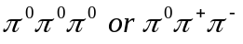
b) 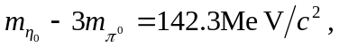 so the kinetic energy of the 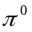 mesons is 142.3 MeV. For the other reaction,

